**Module 15)**

**HTML in Full Stack**

**1. HTML Basics**

**Theory Assignment**

**1) Define HTML. What is the purpose of HTML in web development?**

HTML stands for HyperText Markup Language, it is a standard markup language to design the structure of a webpage. HTML is the combination of HyperText and Markup Language.

* **HyperText:** defines the internal links between web pages. It means HyperText refers to the system used to annotate and format the content, defining the layout, structure and presentation of text, images and multimedia.
* **Markup Language**: It defines the layout and presentation of text and media.

The primary purpose of HTML in web development is to create the basic framework of a website, organizing content in a meaningful and accessible way for users and browsers.

**2) Explain the basic structure of an HTML document. Identify the mandatory tags and their purposes.**

The basic structure of an HTML document contains the few mandatory tags that must be used to create a webpage. This structure must be followed to create any type of HTML document.

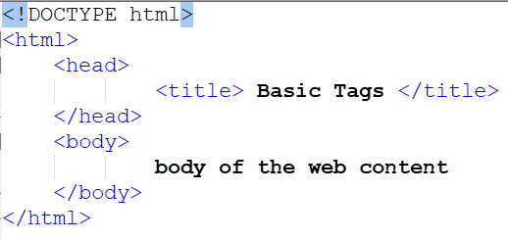

* **<!DOCTYPE> :** This tags declares the document type and version of HTML5 being used.
* **<html> :** The root element of an HTML page, that wraps all the content of the webpage.
* **<head> :** head tag contains meta-information about the document (HTMLpage), such as the title, character encoding, style and scripts.
* **<title> :** Sets the title of the HTML page, which appears in the browser tab.
* **<body> :** Body tag defines the document body. It is a container for all the visible content of webpages such as heading, paragraphs, text, table, list images, link or other elements.

These elements form the foundation of every HTML page and ensure the document is properly structured for web browsers to interpret and display it correctly.

**3) What is the difference between block-level elements and inline elements in HTML? Provide examples of each.**

In HTML, elements are categorized as block-level or inline based on how they behave in the layout of the page.

* **Block-level elements**
* Always starts on a new line.
* Take up the available full width (by default)
* Used to structure the main parts of a webpage.

**Tags:**

**<div>** It is used as a container to group section of content or elements together for CSS style or JavaScript

**<p>** It is used to define a block of text or paragraph. This tag automatically adds spacing before and after.

**<h1> to <h6>** This heading tags represents different levels heading. In which <**h1>** is the most important and <**h6>** is the least important or smallest heading tag.

**<section>** Section of content, It means groups related content under a thematic unit, like a chapter or topic. This tag ofter used with a heading.

**<article>** Independent content, It represents self-contained content, such as a blog, post or news article. It can stand alone or be reused.

**<ul>** Unordered list, this tag creates a list with bullet points.

**<ol>** Ordered List, this <ol> tag creates a numbered list.

**<li>** It is used to list the items. **<li>** tag used **<ul>** or **<ol>** to define individual items.

* **Inline elements**
* Do not start on a new line.
* Only take up as much width as necessary.
* Used to style or modify parts of content inside block-level elements.

**Tags:**

**<span> Generic inline container**

<span> tag used to group inline elements or text for styling or scripting. By default it has no visual effect.

**<a> Anchor tag or hyperlink**

anchor tag creates a hyperlink to another page, section or website.

**<image>** This tag is used to display an image in the page. It is correctly written as **<img>,** which is self closing tag.

**<strong>** Strong importance (Browsers usually render it as bold)

**<em>** It is used to emphasize the text. (Browsers usually render it as italic)

Block-level elements define the overall structure of the page, while inline elements handle small pieces of content inside blocks without breaking the flow.

**4) Discuss the role of semantic HTML. Why is it important for accessibility and SEO? Provide**

Semantic HTML refers to HTML elements that clearly describe their meaning or purpose in the structure of a webpage. Instead of using non-descriptive tags like <div> or <span>, semantic elements such as <header>, <footer> and <article> define the role of each content block.

**Importance of Semantic HTML**

1. **Improve Accessibility:** Semantic elements help screen readers & assistive technologies understand the layout and content of the page. This makes the website more accessible for users with disabilities (blind users using screen readers)

**<nav>** tells screen readers this is the navigation area and **<main>** defines the primary content.

1. **Boosts SEO (Search Engine Optimization):** Search engines like Google use semantic tags to better understand & index the content. This helps improve the visibility of your website in search results.

Using **<article>** tag for blog posts helps search engines recognize each post as separate, valuable content.

1. **Cleaner & Easier Code for Developers:** Semantic HTML makes the code easier to read, maintain and collaborate on, since the structure is self-explanatory.

**examples of semantic elements.**

|  |  |
| --- | --- |
| Element | Description |
| <header> | Represents the top section (logo, title, nav) |
| <footer> | Represents the bottom section (copyright) |
| <main> | Contains the primary content of the page |
| <nav> | Used for navigation links |
| <article> | Represents self-contained content |
| <section> | Groups related content together |
| <aside> | Side content like tips, ads or related links |

**(Lab Assignment Task )**

Create a simple HTML webpage that includes )

* A header (), footer (), main section (), and aside section ().
* A paragraph with some basic text.
* A list (both ordered and unordered).
* A link that opens in a new tab.

<!DOCTYPE html>

<html lang="en">

<head>

    <meta charset="UTF-8">

    <meta name="viewport" content="width=device-width, initial-scale=1.0">

    <title>Document</title>

</head>

<body>

    <header>

        <h1> My Semantic Webpage  </h1>

        <nav>

            <a href="#"> Home </a>

            <a href="#"> Contact </a>

        </nav>

    </header>

        <main>

            <section>

                <h3> Welcome!</h3>

                <p> This is a simple webpage that demonstrates semantic HTML elements and their use in web development.</p>

                <h4> Unordered List (Fruits) </h4>

                <ul>

                    <li> Apple </li>

                    <li> Banana </li>

                    <li> Mango </li>

                </ul>

                <h4> Ordered List (steps to study)</h4>

                <ol>

                    <li> Make a timetable </li>

                    <li> Read your notes </li>

                    <li> Practice questions </li>

                    <li> Revise regularly </li>

                </ol>

                <p> Visit <a href="https://www.w3schools.com/html/html5_semantic_elements.asp"> this link </a> to learn more.</p>

            </section>

        </main>

        <aside>

             <h4> Quick Tip </h4>

             <p> Use semantic tags to make your code easier to understand and improve your website's accessibility and SEO.</p>

        </aside>

        <footer> @2025 My Webpage. All rights reserved. </footer>

    </body>

</html>

**Output:**

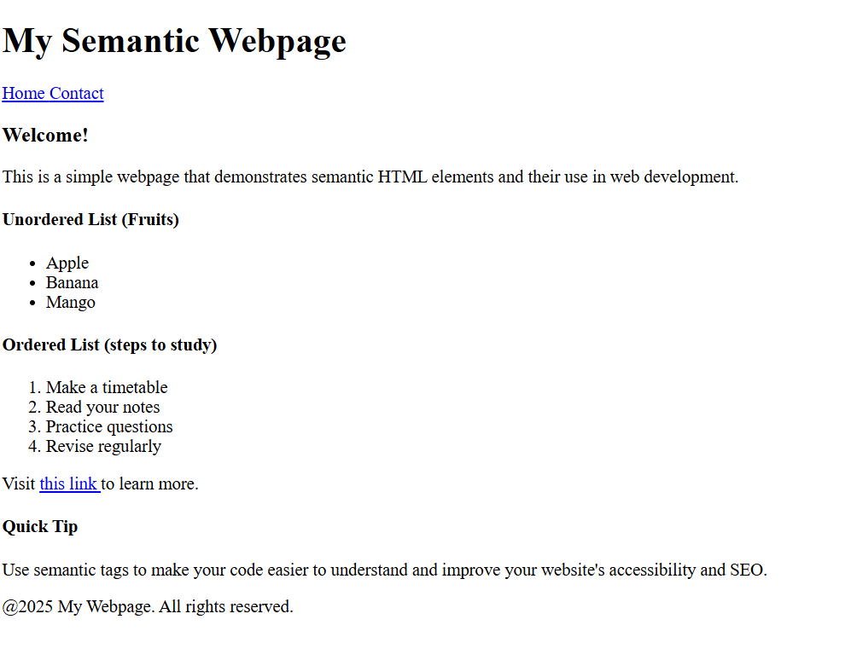

**2. HTML Forms Theory Assignment**

1. What are HTML forms used for? Describe the purpose of the input, textarea, select, and button elements.

HTML forms are used to collect user input and send data to a server for processing. Forms are commonly used in webpages for tasks such as:

* User registration
* Login
* Feedback submission
* Searching
* Placing orders

A form is created using the <form> tag, and it contains input elements like text fields, dropdowns, checkbox and buttons.

Common Form elements and their purpose:

* **<input>**

The <input> element is used to get different types of user input such as:

* Text (<input type=”text”)
* Password (<input type=”password”>)
* Email, number, checkbox, radio, data, etc.

<input type=”text” value=”name” placeholder=”Enter your name”>

* **<textarea>**

Used to collect multi-line text input, such as messages or comments.

<textarea value=”message” name=”message” rows=”5” cols=”30”>Enter your message here…</textarea>

* **<select>**

Creates a drop-down list. It is used when users need to choose from a list of predefined options.

<select name="country">

    <option> India </option>

    <option value="india"> USA </option>

    <option value="canada"> Canada </option>

    <option value="dubai"> Dubai </option>

</select>

* **<Button>**

Defines a clickable button, usually for submitting the form.

<button type="submit">

        submit

</button>

<input type="submit" value="submit">

HTML forms allow user interaction with a webpage by collecting data through various input types, which can then be processed or stored by a server.

1. Explain the difference between the GET and POST methods in form submission. When should each be used?

|  |  |
| --- | --- |
| GET Method | Post Method |
| GE.T method is used to request data from a specified resource. | POST method is used to send data to a server to create/update a resource. |
| The query string (name/value/pairs) is sent in the URL of a GET request | The data sent to the server with POST is stored in the request. |
| GET requests can be cached | POST requests are never cached |
| GET requests remain in the browser history | POST requests do not remain in the browser history |
| GET requests can be bookmarked | POST requests can not be bookmarked |
| GET requests should not be used when dealing with sensitive data (ex. Password) | POST requests have no restrictions on data length. |
| GET requests have length restrictions.  (due to URL length limits) | POST requests have no significant data length limit. |
| GET is used for retrieving data, not for modifying server state. | POST is used when data is submitted to change or update server state |
| Data is visible to everyone in the URL | Data is hidden from URL |
| GET is less secure because data appears in browser history and server logs. | POST is more secure as data is not stored in browser history or logs. |

3) What is the purpose of the label element in a form, and how does it improve accessibility?

The **<label>** element is used to define a text label for form input elements like <input>, <select> or <textarea>. It helps users understand what information is expected in each form field. This tag improves usability, accessibility and form clarity, especially for users relying on assistive technologies.

<label for="email"> Email: </label>

<input type=""email" id="email" name="email">

How it is work

* **Screen Readers Support:** Screen readers read the label aloud, so visually impaired users can understand the purpose of the input field.
* **Larger Clickable Area:** Clicking the label will also focus the input field, which is helpful for users can understand the purpose of the input field.
* **Clear Instruction:** Labels provide clear context for users, reducing input errors.
* **Required for accessibility standards:** Proper use of <label> is part of WCAG (Web Content Accessibility Guidelines) for building accessible web forms.

(Lab Assignment Task )

Create a contact form with the following fields )

* Full name (text input)
* Email (email input)
* Phone number (tel input)
* Subject (dropdown menu)
* Message (textarea)
* Submit button Additional Requirements )
* Use appropriate form validation using required, minlength, maxlength, and pattern.
* Link form labels with their corresponding inputs using the for attribute.

<!DOCTYPE html>

<html lang="en">

<head>

    <meta charset="UTF-8">

    <meta name="viewport" content="width=device-width, initial-scale=1.0">

    <title>Contact Form</title>

</head>

<body>

        <form method="POST">

            <fieldset>

                <h4> Contact form </h4>

                <table>

                        <tr>

                            <td><label for="fullname"> Full Name:</label></td>

                            <td><input type="text" id="name" placeholder="Enter your full name" name="full name" required minlength="3" maxlength="50"/> </td>

                        </tr>

                        <tr>

                            <td><label for="email">Email: </label> </td>

                            <td><input type="email" id="email" placeholder="Enter your email id" name="email" required/> </td>

                        </tr>

                        <tr>

                            <td><label for="phone number"> Phone Number: </label> </td>

                            <td><input type="tel" id="contact" placeholder="Enter 10-Digit mobile number" name="Phone Number" required pattern="[0-9]{10}"/></label></td>

                        </tr>

                        <tr>

                            <td><label for="subject"> Subject: </label> </td>

                                    <td><select name="subject" required>

                                            <option> ----select----</option>

                                            <option id="maths"> Maths </option>

                                            <option id="bio"> Bio </option>

                                            <option id="commerce"> Commerce </option>

                                            <option id="art"> Art </option>

                                            <option id="agriculture"> Agriculture </option>

                                    </select>

                                    </td>

                        </tr>

                        <tr>

                            <td><label for="message"> Message: </label> </td>

                            <td><textarea id="message" name="message" placeholder="Enter your message here..."></textarea> </td>

                        </tr>

                        <tr>

                            <td><input type="submit" id="submit" value="submit"></td>

                        </tr>

                </table>

            </fieldset>

        </form>

</body>

</html>

Output:

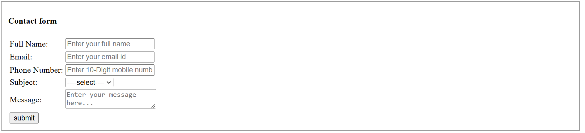

**3. HTML Tables**

**Theory Assignment**

1. Explain the structure of an HTML table and the purpose of each of the following elements:

<table>, <tr>, <th>, <td> and <thead>.

An HTML table is used to display tabular data in rows and columns. The main elements that build an HTML table are:

**<table>** tag defines the beginning and end of the table. It is the container for all other table-related elements like rows and cells.

**<table>**

**(Tabular data)**

**</table>**

**<tr> (Table Row)** this tag defines a row in the table. It groups together table cells (<th> or <td> ) into a row.

**<tr>**

**<td>Data 1</td>**

**<td>Data 2</td>**

**</tr>**

**<th> (Table Head)** this tag defines a header cell in the table. This tag usually used inside the <thead> or the first <tr> to label columns. <th> texts has default style like bold and centered alignment.

**<tr>**

**<th>Name</th>**

**<th>Age</th>**

**</tr>**

**<td> (Table Data Cell)** This tag defines a regular data cell in the table. It contains the actual data values for each row and column.

**<tr>**

**<td>John</td>**

**<td>25</td>**

**</tr>**

**<thead> (Table Head)** This tag groups the header content of the table. It is used for better structure and readability and useful when styling or printing tables. But recommanded when separating table header from body (<tbody>).

**<thead>**

**<tr>**

**<th>Name</th>**

**<th>Age</th>**

**</tr>**

**</thead>**

1. What is the difference between colspan and rowspan in tables? Provide examples.

**HTML Table- Colspan**

Makes a cell span multiple columns horizontally.

To make a cell span over multiple columns, use the colspan attribute.

Use when want to one cell to take the space of two or more columns.

Th value of the colspan attribute represents the number of columns to span.

**HTML Table- Rowspan**

Makes a cell span multiple rows vertically.

To make a cell span over multiple rows, use the rowspan attribute.

Use when want one cell to cover two or more rows.

The value of the rowspan attribute represents the number of rows to span.

|  |  |  |  |
| --- | --- | --- | --- |
| Attribute | Span Across | Direction | Used in |
| colspan | Columns | Horizontal | <td>, <th> |
| rowspan | Rows | Vertical | <td>, <th> |

<html>

    <head>

            <title> Time table </title>

    </head>

    <body>

            <table border="5" align="center" cellpadding="5" cellspacing="0">

                <tr align="center">

                    <td colspan= "6"> Time Table </td>

                </tr>

                <tr>

                    <th rowspan ="6">  Hours </th>

                    <th> Mon </th>

                    <th> Tue </th>

                    <th> Wed  </th>

                    <th> Thu </th>

                    <th> Fri </th>

                <tr>

                    <td> Math </td>

                    <td> Science </td>

                    <td> Math </td>

                    <td> Science </td>

                    <td> Arts </td>

                </tr>

                <tr>

                    <td> Math </td>

                    <td> Science </td>

                    <td> Math </td>

                    <td> Science </td>

                    <td> Arts </td>

                </tr>

                <tr>

                    <td align="center" colspan="5"> Lunch </td>

                </tr>

                <tr>

                    <td> Math </td>

                    <td> Science </td>

                    <td> Math </td>

                    <td rowspan="2" colspan="2" align="center"> Project </td>

                </tr>

                <tr>

                    <td> Math </td>

                    <td> Science </td>

                    <td> Math </td>

                </tr>

            </table>

    </body>

</html>

Output:

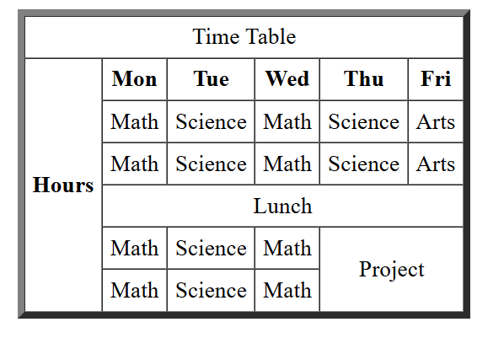

3 ) Why should tables be used sparingly for layout purposes? What is a better alternative?

Using HTML <table> elements for page layout (instead of just displaying tabular data) is not recommended in modern web development.

**Problem with Using Tables for Layout:**

* **Not Semantic:** Tables are meant for tabular data, not layout. It confuses screen readers and accessibility tools.
* **Poor Accessibility:** Users with disabilities (like screen readers users) may struggle to understand content if tables are misused.
* **Difficult to maintain:** Layout using tables are hard to edit or redesign later, especially in large project.
* **Not responsive:** Tables do not adapt well to different screen sizes, causing layout issue.
* **Bloated HTML:** Requires more complex and nested HTML making the code longer and harder to bedug.

**For Better alternative: CSS (Cascading Style Sheets)**

Use CSS with **<div>** and other **semantic tags** like:

* **<header>**
* **<section>**
* **<article>**
* **<footer>**
* **<main>**

**CSS allows for:**

* Responsive design using mobile queries.
* Cleaner, more maintainable code
* Separation of content and design

**Lab Assignment Task )**

1. Create a product catalog table that includes the following columns )

* Product Name o Product Image (use placeholder image URLs)
* Price
* Description o Availability (in stock, out of stock) Additional Requirements )
* Use thead for the table header.
* Add a border and some basic styling using inline CSS.
* Use colspan or rowspan to merge cells where applicable.

<!DOCTYPE html>

<html>

    <head>

        <title> Table </title>

        <style>

            table {

                width: 90%;

                margin: auto;

                border-collapse: collapse;

                border: 2px solid #333;

                font-family: Arial, sans-serif;

            }

            th, td {

                border: 1px solid #333;

                padding: 10px;

                text-align: left;

            }

            thead {

                background-color: #f2f2f2;

            }

            h2 {

                text-align: center;

            }

            img {

                width: 100px;

                height: auto;

            }

        </style>

    </head>

    <body>

        <h2>Annu's Fashion</h2>

        <table>

            <thead>

                <tr>

                    <th>Product Name</th>

                    <th>Image</th>

                    <th>Price</th>

                    <th>Description</th>

                    <th>Availability</th>

                </tr>

            </thead>

            <tbody>

                <tr>

                    <td>Summer Wearable Soft Saree</td>

                    <td><img src="D:\Downloads\WhatsApp Image 2025-02-18 at 12.31.27.jpeg" alt="Floral Dress"></td>

                    <td>₹1,299</td>

                    <td> Beautiful  white colored saree with red colored readymade blouse<strong><br>Fabric:</strong>cotton silk <strong><br> color: </strong> offwhite <strong><br>blouse:</strong> stitched </td>

                    <td>In Stock</td>

                </tr>

                <tr>

                    <td>Floral Print Black Saree</td>

                    <td><img src="D:\Downloads\WhatsApp Image 2025-02-20 at 12.13.59.jpeg" alt="Denim Jacket"></td>

                    <td>₹1,999</td>

                    <td> Beautiful Partywear black print saree heavy blouse<strong><br>Fabric:</strong>Khadi cotton <strong><br> color: </strong> black print on white fabric <strong><br>blouse:</strong> stitched, Un-stitched </td>

                    <td>Out of Stock</td>

                </tr>

                <tr>

                    <td>Partywear Saree</td>

                    <td><img src="D:\Downloads\WhatsApp Image 2025-02-20 at 13.40.51.jpeg" alt="Kurti Set"></td>

                    <td>₹4,499</td>

                    <td> Beautiful partywear embroidery saree with heavy border and partywear blouse<strong><br>Fabric:</strong> Georgette <strong><br> color: </strong> voilet <strong><br>blouse:</strong> stitched, Un-stitched </td>

                    <td>In Stock</td>

                </tr>

                <tr>

                    <td colspan="5">Festive Offer: ₹200 off on purchase above ₹2000</td>

                </tr>

            </tbody>

        </table>

    </body>

</html>

Output:

